How stress affects anxiety, fatigue and chronic illness

Chronic Fatigue Syndrome And Natural Killer Cells

By Dan Kenner, Ph.D., OMD

Stress causes real illness
Doctors who still doubt whether Chronic Fatigue Syndrome (CFS) is “real” cite the wide diversity of physical and mental symptoms it presents, and the lack of a proven single causative agent or virus. But research on how stress effects the immune system, in particular Natural Killer (NK) cell function, is providing a new and more comprehensive model to explain the onset and progression of CFS and its variety of physicals, cognitive and emotional symptoms.

Natural Killer (NK) cells are a type of white blood cell referred to as the “sentinel” cells of the immune system. Like the sentinels of a fort, they are the first to encounter invading viruses, bacteria, and emerging malignancies. They have an innate or “natural” ability to distinguish between the good guys and the bad guys, and can kill multiple target cells simultaneously or in quick succession. When NK cell function is high, pathogens are nipped in the bud, before they can take root, and the rest of the immune system tends to be down-regulated, rested and better prepared to respond if called upon.

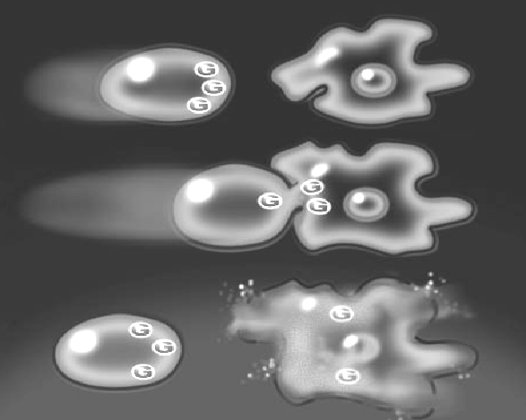

How NK cells work

NK cells inject invader cells with cytotoxic granules(G). Invaders “explode” as granule lysis dissolves their cell membranes

The mind-body connection
The connection between stress and chronic fatigue comes as a result of the interactions of the immune system with the nervous and endocrine systems studied in the emerging field of psycho-neuro-endocrine-immunology. When confronted by emotional or physical stress, the brain produces a neurotransmitter called Substance Y that helps initiate the “fight or flight” response. It directly suppresses NK cell function and other aspects of cellular immunity that relate to innate immunity.

The body compensates by up-regulating humoral immunity, specifically increasing inflammatory cytokines that enhance aspects of acquired immunity that increase antibody production, and hormones that cause fluctuations in body temperature, and generally make the body a hostile environment.

Up-regulation of humoral immunity and the inflammatory response for short periods of time can speed recovery and is good for health. But when emotional and physiological stress is extremely severe or of long duration, inflammatory cytokines themselves suppress NK cell function and the condition becomes self-perpetuating. This can also happen when several stresses occur simultaneously or coincide with NK cell suppression that naturally occurs at the time of ovulation in women.

Different types of stress – similar effects
The concepts of psychoneuroimmunology provide a unified theory that encompasses the many mental and physical stresses that may lead to CFS with its many medical and psychological symptoms. Emotional stresses such as grief and fear are shown to suppress cellular immunity and favor inflammatory immune responses, as are physical stresses such as heavy metal poisoning, chemical exposure, nutritional deficiencies, hormone imbalances, accidental injury and medical procedures.

The psychological symptoms that correspond with low NK cell function include fatigue, exaggerated pain responses, altered sleep patterns, decreased libido, anxiety, depression, cognitive and memory problems. The physical symptoms include chemical and allergic sensitivity, recurrent flu-like symptoms, and muscle and joint stiffness.

There are many aspects of altered immune response, but in studies of post-traumatic stress disorders, only suppressed NK cell function consistently predicted the future onset of chronic illness. In the case of CFS, the severity of many mental and physical symptoms correspond with the degree of NK cell impairment.

Reducing stress effects with AHCC
Many common stress reducing methods such as regular exercise, music, massage, and just smiling itself can increase NK cell activity. And many NK cell-enhancing strategies can reduce the effects of stress as studies of the immune enhancing supplement AHCC have shown.

AHCC (Active Hexose Correlated Compound) is made from a fermented extract of a hybrid of mushrooms used in traditional Japanese medicine. It is distinguished from other mushroom supplements by its low molecular weight, 5,000 daltons, and alpha-glucan structure. Published studies by several groups of researchers in the U.S. and Japan have shown that taken orally AHCC can up-regulate NK cell function by several hundred percent, with associated increases in the cytokines IL-2 and IL-12 that are generally associated with the down-regulation of inflammatory cytokines.

AHCC is widely used in Japan, in over 600 hospitals, for the treatment of cancer, hepatitis and other chronic diseases because of the supporting research specific to these conditions.

Research in models of physical and chemically-induced stress showed that AHCC reduced glucocorticoid production normally up-regulated by stress, and reduced increases in blood sugar level caused by stress-induced secretion of epinephrine. Physicians and psychologists who treat CFS and their patients have reported improvements in mood, energy and pain with the use of AHCC, consistent with the model that up-regulating NK cell function helps to reduce the adverse effects that stress has on the response of the nervous, endocrine and immune systems to stress.

- Nair MP, et al."Effect of neuropeptide Y on natural killer activity of normal human lymphocytes," Brain Behav Immun Mar;7(1): 70-8, 1993.
- Whiteside TL, Herberman RB, "The association of abnormalities in NK cell numbers or functions with a broad spectrum of human diseases has been more clearly defined in recent years" Clin Diagn Lab Immunol Mar;1(2):125-33, 1994.
- Raison CL, Miller AH., “The neuroimmunology of stress and depression,” Semin Clin Neuropsychiatry 2001 Oct;6(4):277-94
- Glaser R, Kiecolt-Glaser JK., “Stress-associated immune modulation: relevance to viral infections and chronic fatigue syndrome,” Am J Med 1998 Sep 28;105(3A):35S-42S
- Whiteside TL, Friberg D., “Natural killer cells and natural killer cell activity in chronic fatigue syndrome,” Am J Med 1998 Sep 28;105(3A):27S-34S
- Matsui Y, et al., “Preventive Effect of Active Hexose Correlated Compound (AHCC) on the Recurrence of Postoperative Hepatocellular Carcinoma Patients,” XXXIIIrd Congress of the European Society for Surgical Research, 1998 p74
- Wang S,et al. “AHCC on Immobilization Stress in the Rat: Beneficial Effects of Active Hexose Correlated Compound” Dokkyo Journal of Medical Sciences p. 559 28(1): 559 ~ 565, 2001

